Housemate Helper

OVO

Completion: 10/19/21

Revision 1: 10/5/21

Sprint 1 Plan

Sprint Goal:

Complete the account creation and group creation/joining features of the application.

Task Listing:

* User story 1: As a housemate, I want to be able to create an account and login so that I can use the application as a whole.
  + Task 1: Establish application framework (1 hour)
  + Task 2: Create login page for user to create an account (1 hour)
* User story 2: As a housemate, I want to be able to create a house group so that my housemates can join.
  + Task 1: Establish database connection so the application can store all the house groups (2 hours)
  + Task 2: Establish password authentication for house groups (1 hour)
* User story 3: As a housemate, I want to be able to join a house so that I can coordinate and use the features of the app with the rest of my housemates.
  + Task 1: Create feature to join house group (1 hour)
  + Task 2: Establish database for house members for each house group (2 hours)

Team Roles:

* Matthew Atmadja: Product Owner, Developer
* Vinay Prasad: Scrum Master, Developer
* Rishab Aida: Developer
* Ashvini Bhupatiraju: Developer
* Sukhveer Karlcut: Developer
* Rishika Patel: Developer

Initial Task Assignments:

* Learn Firebase and React: Everyone
* Establish application framework: Everyone

Initial Burnup Chart

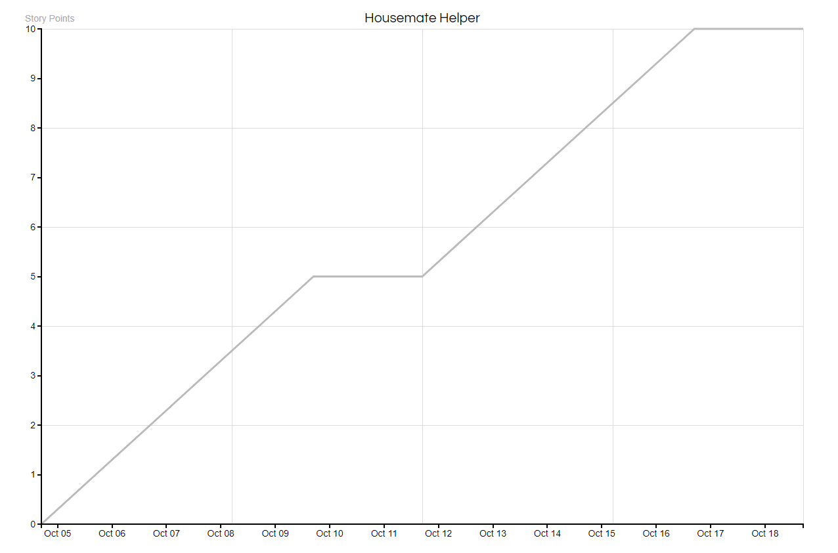

Initial Scrum Board:

| Stories | To Do | In Progress | Done |
| --- | --- | --- | --- |
| User Story 1 | * Establish framework * Login authentication |  |  |
| User Story 2 | * House database * House group authentication |  |  |
| User Story 3 | * House member database |  |  |

Scrum Times:

* Team meets every Tuesday, Thursday, Saturday